Key Facts and Figures – CERN Data Centre
As of 8 October 2018_V1

General Information
Websites
Latest numbers: https://cern.ch/go/datacentrebynumbers
(Or if you are not on CERN site: http://go.web.cern.ch/go/datacentrebynumbers)
How to use the Data Centre visit point (please sign in to access that page): http://www.cern.ch/information-technology/about/computer-centre/visits/visitpoint

Key facts and numbers
 |  |  | Meyrin Data Centre |  | Wigner Extension |  | TOTAL
 | Servers |  | 11 500 |  | 3 500 |  | 15 000 => 15 K
 | Processor cores |  | 174 300 |  | 56 000 |  | 230 300 => ≃ 230 K
 | Disks |  | 61 900 |  | 29 700 |  | 91 600 => ≃ 90 K (units)  (about 280 PB capacity but data is copied twice on disks)
 | Tape Cartridges |  |  |  |  |  | 32 200 => ≃ 30 K (units)  (about 400 PB capacity)

Short overview

The CERN data centre is the heart of CERN’s entire scientific, administrative, and computing infrastructure. All services, including email, scientific data management and videoconferencing use equipment based in the data centre.

A remote extension of the CERN data centre is hosted at the Wigner Research Centre for Physics in Budapest, Hungary, 1200 km away. It provides the extra computing power required to cover CERN’s needs.

The 230 000 processor cores and 15 000 servers run 24/7.

On 29 June 2017, the CERN Data Centre passed the milestone of 200 petabytes of data permanently archived in its tape libraries. At the end of September 2018, 297 PB of data were permanently archived on tapes in the CERN data centre.

New record in August 2018: 13.8 petabytes of data (from all sources) were written on tape that month.

Usually more than 2PB are being accessed (read and write) every day. The LHC data are aggregated in the CERN Data Centre, where initial data reconstruction is performed, and a copy is archived to long-term tape storage. Another copy is sent to several large-scale data centres around the world. Subsequently hundreds of thousands of computers from around the world come into action: harnessed in a distributed computing service, they form the Worldwide LHC Computing Grid (WLCG).

STORAGE:
Websites:
www.cern.ch/eos
www.cern.ch/castor
https://filer-carbon.cern.ch/grafana/dashboard/db/castor-dashboard?orgId=1

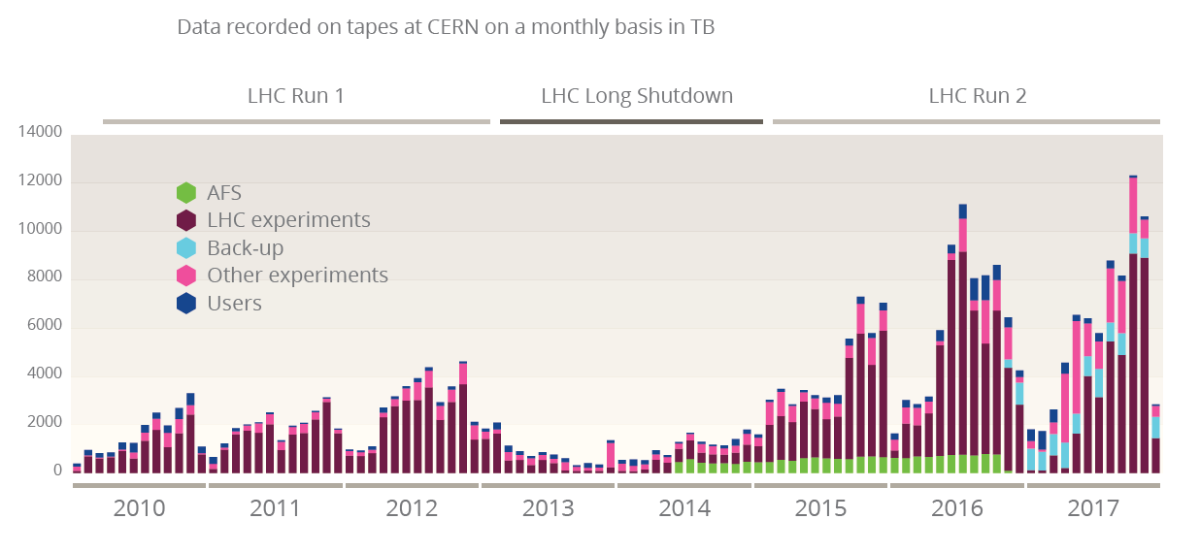
This plot shows on a monthly basis the amount of data recorded on tape generated by the LHC experiments, the other experiments, various back-ups, and the users. In 2017, 72 petabytes of data in total (among which 40 petabytes of LHC data) were recorded to tape with a record peak of 12.3 petabytes in October 2017.

Magnetic tapes are used as the main long-term storage medium.
We have many tape robots to ensure efficient storage and retrieval of data.
- The amount of data recorded on tape at CERN is steadily increasing over time, with this trend accelerating over time (+40 % data stored in 2016 compared to what had been accumulated by the end of 2015 for instance).
- 11.56 PB of LHC data alone was written to tape in August 2018, a new record.
- So far in 2018, around 78PB of new data (out of which 60PB LHC data) has been written to tape. In addition and during the first months of 2018, 100PB of data have been migrated (“repacked”) to higher-density cartridges.
- In 2017, 40 PB of LHC data were recorded at the CERN data centre on tapes. In total 72 PB of data were recorded on tapes (from LHC and non LHC experiments, etc.) with a striking 12.3 PB in the month of July alone.
- In 2016, more than 49 petabytes of LHC data were recorded at the CERN data centre on tapes. In total, 73 PB of data were recorded on tapes (from LHC and non LHC experiments, etc.) with a striking 11 PB in the month of July alone.
- 297 PB of data were permanently archived on tapes in the CERN data centre at the end of September 2018.
- While tape drives are faster than disk drives, latency for accessing tape data is relatively high. It takes about 1-3 minutes from tape being located and mounted on a tape drive before data can be read. Often physicists need to access the latest data immediately, so it is also made available on disk servers, where latency delays are significantly lower.
- There are currently about 90,000 disks in the CERN data centre with a capacity of about 280 PB. 10-15% of the 90,000 of the disk drives are SSD ones (but it represents far less than 10% of the capacity itself). For the high capacity storage (~260 PB) used for the physics data in CASTOR and EOS, CERN uses normal mechanical (spinning) disk drives since the price per terabyte is significantly lower (5-10x).
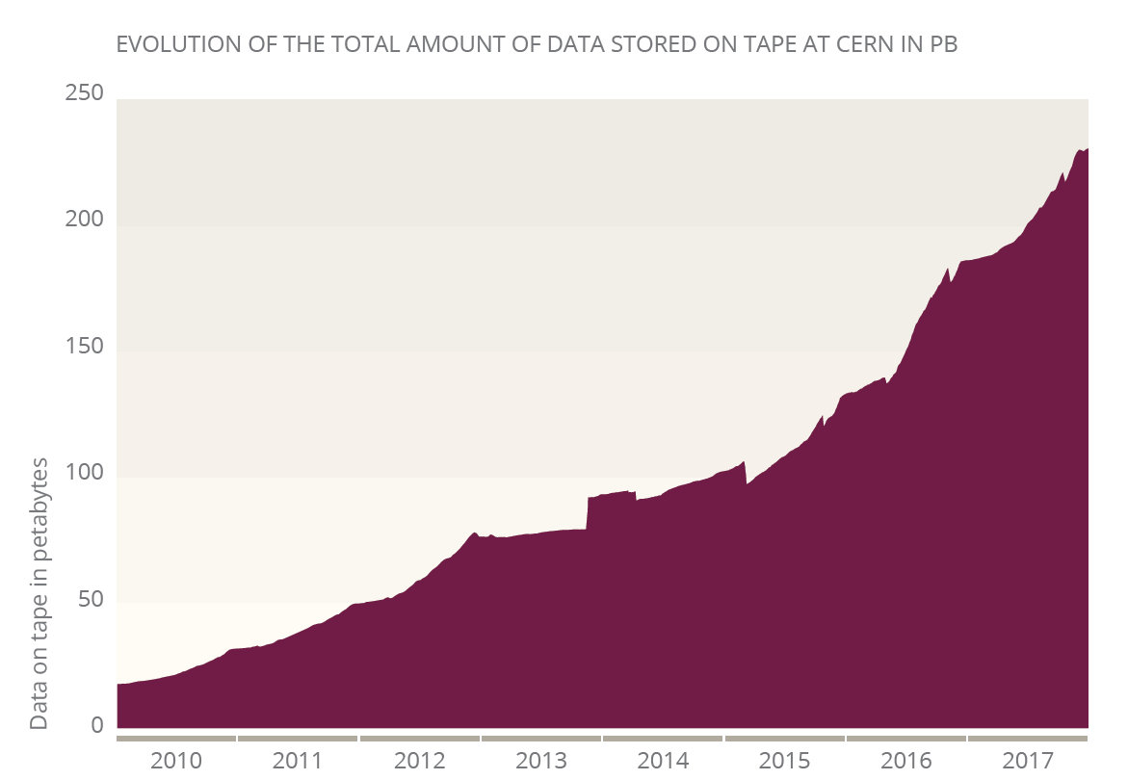
As seen on the graph, the amount of data recorded on tape at CERN is steadily increasing over time. A milestone of 200 petabytes of data stored on tape was reached on 29 June 2017 while by the end of 2017 a total of 230 petabytes had been stored.

- http://home.cern/about/updates/2017/07/cern-data-centre-passes-200-petabyte-milestone: On 29 June 2017, the CERN Data Centre passed the milestone of 200 petabytes of data permanently archived in its tape libraries. Where do these data come from? Particles collide in the Large Hadron Collider (LHC) detectors approximately 1 billion times per second, generating about one petabyte of collision data per second. The detectors can be compared to digital cameras with 100 million electronics channels that would be taking over 40 million pictures per second (which currently corresponds to 1 billion proton-proton interactions per second).
- However, such quantities of data are impossible for current computing systems to record and they are hence filtered by the experiments, keeping only the most “interesting” ones. The filtered LHC data are then aggregated in the CERN Data Centre, where initial data reconstruction is performed, and where a copy is archived to long-term tape storage. Even after the drastic data reduction performed by the experiments, the CERN Data Centre processes on average one petabyte of data per day. If we keep the digital camera analogy, that would mean that we only keep a 1000 pictures per second out of the 40 million we initially had.
- As of end of September 2018, there are 297 PB on tapes and the total capacity on tapes reaches 400 PB (this can be extended as much as needed though).
- As of end of September, we have 186 PB on disks and a total capacity of 280 PB on disks. However, as disks are not reliable (a thousand times less than tapes, 30 disks fail each week in the data centre), we always copy twice the data on disk so that if a disk fails we do not lose data => so ‘only’ 93 PB of ‘real’ data is on disks at the moment and the ‘real’ capacity is about 150 PB.
- The CERN storage system, EOS, was created for the extreme LHC computing requirements. In 2018, EOS instances at CERN exceed three billions files, matching the exceptional performances of the LHC machine and experiments.

ELECTRICITY:
- 2.7 megawatt computing power consumption (cooling not included and represents roughly one additional megawatt) from a maximum of 3.5 megawatt
- Data centre protected by UPS (Uninterruptable Power Supply) => Allows to start diesel generators for critical systems and provides time to shut down non-critical systems
- The electrical infrastructure is a vital element of the data centre. Strategies for increasing power efficiency are permanently investigated to be able to maximise the computing power serving the CERN’s infrastructure and scientific programme whilst staying within the 3.5 megawatt electrical capacity envelope available in the data centre.
- In the case of a major electrical cut, Uninterruptible Power Supplies (UPS) provide time for all the non-critical systems to be properly shutdown and a combination of UPS systems and diesel generators ensure that the critical services keep working.

COOLING:
- About 1.4 megawatt is dedicated to the cooling of the data centre.
- Main Machine room: chilled air via silver ducts, into false floor and then into closed server aisles. We also use water-cooled racks in some areas (basement: ‘vault’).

Efficient cooling is a key element of the data centre. When the outside temperature is low, air can be used to cool the servers, otherwise chiller systems are used to cool the data centre air. Cold air is distributed via the silver ducts on the sides of the data centre room. It then goes under the false floor and into the closed server aisles through the perforated floor tiles, to be drawn finally through the servers to cool them. Some servers are water-cooled using active or passive heat exchangers in their rear doors, providing a higher cooling capacity per rack.

WLCG – Worldwide LHC Computing Grid

Websites:
www.cern.ch/wlcg
www.cern.ch/wlcg-public

Key facts and numbers:
- More than 170 data centres in 42 countries with about 800,000 cpu cores
- CERN provides about 20% of the WLCG resources
- Allows more than 10,000 physicists to access LHC data
- >250,000 jobs run concurrently on the Grid
- Storage is about 400 PB disk and 400 PB of tape globally
- In 2016, global transfer rates have regularly exceeded 35GB/s

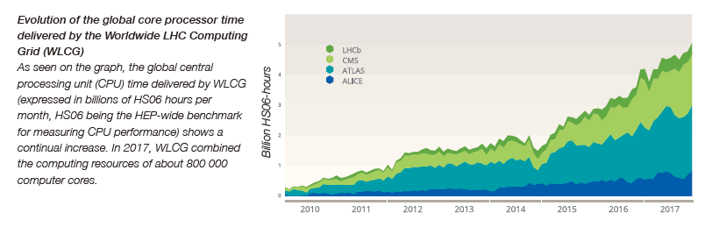
Short overview:
Today, the Worldwide LHC Computing Grid (WLCG) combines the computing resources of about 800,000 cores from over 170 sites in 42 countries, producing a massive distributed computing infrastructure that provides more than 10000 physicists around the world with near real-time access to LHC data, and the power to process it.
The Worldwide LHC Computing Grid runs over 2,000,000 tasks per day and in 2016, global transfer rates have regularly exceeded 35GB/s.
These numbers will increase as time goes on and as computing resources and new technologies become ever more available across the world.
CERN provides about 20% of the resources of WLCG.

NETWORK:
Webpage:
https://netstat.cern.ch/monitoring/network-statistics/
https://cixp.net/
Key facts and numbers:
- 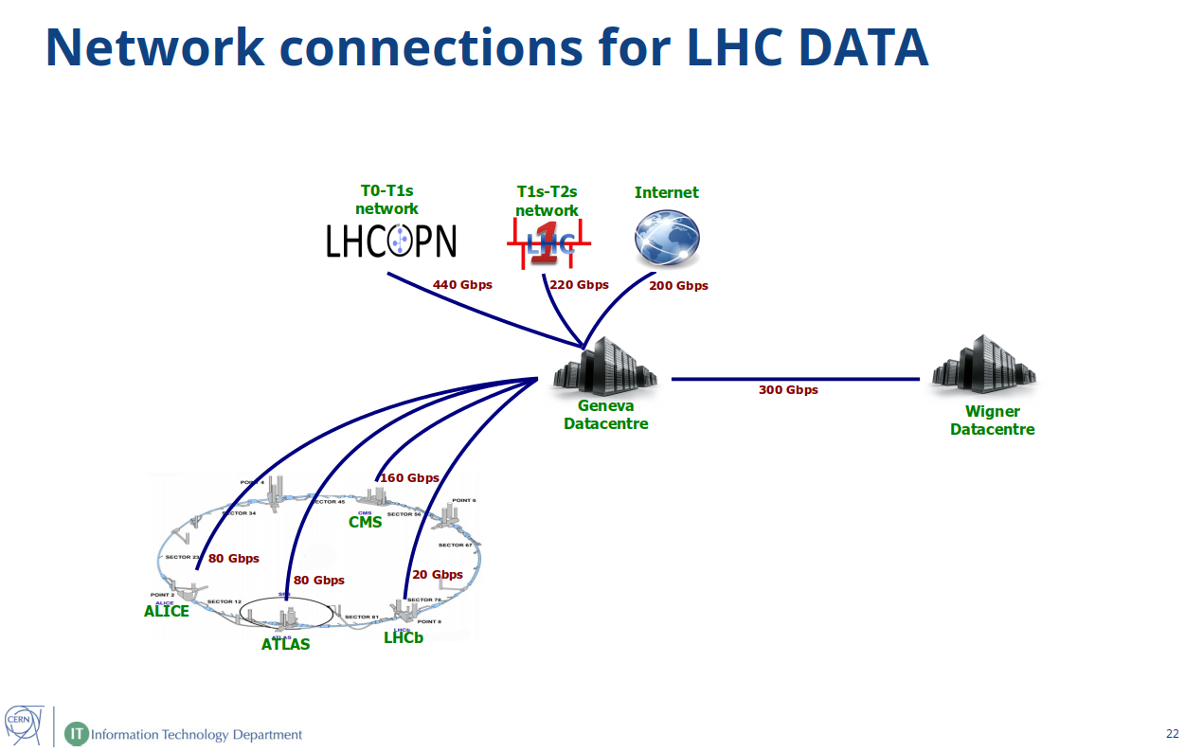Over 35,000 km of optical fibre providing network connectivity throughout the CERN sites.
- Network connections for LHC data:

- Three 100 Gigabit per second circuits connect the Meyrin Data Centre and its extension in Hungary (cf. below).

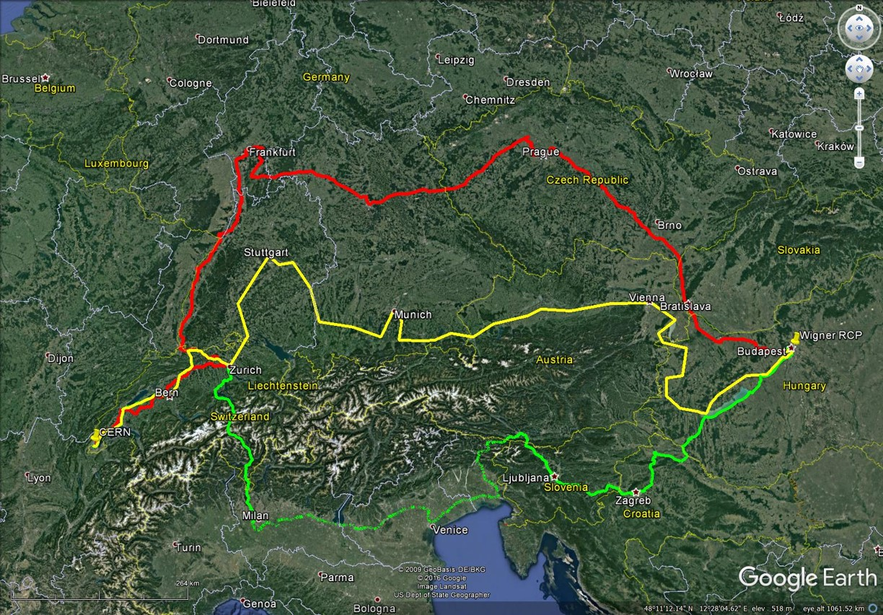
- In 2016 and 2017, the data transfer rates around the globe also reached new peak rates – between 30 and 40 gigabytes per second continuous rates, around a factor of two higher than had been typical during Run 1.
- CIXP: https://cixp.net/, The CERN Internet eXchange Point (CIXP) is a carrier-neutral exchange point based in the CERN data centre. Our partners are telecom operators and ISPs in Switzerland and France, as well as national and international research network operators. The service is provided jointly by CERN and Equinix's data-centres in Geneva and Zurich.
- CERN played a central role in the history of the internet’s development: in 1991, 80% of the internet capacity in Europe for international traffic was installed in the CERN Data Centre. To know more, please check: https://home.cern/cern-people/opinion/2013/06/how-internet-came-cern
Data Preservation:
Cf. computing chapter of the CERN annual report 2016: https://e-publishing.cern.ch/index.php/Annual_Report/article/view/496/354

Open Source:
Cf. computing chapter of the CERN annual report 2016: https://e-publishing.cern.ch/index.php/Annual_Report/article/view/496/354

LHC@home:
www.cern.ch/lhcathome
Volunteer computing for the LHC

CERN openlab:
www.cern.ch/openlab
CERN openlab is a unique public-private partnership that accelerates the development of cutting-edge solutions for the worldwide LHC community and wider scientific research. Through CERN openlab, CERN collaborates with leading ICT companies and research institutes.

EU projects:
www.cern.ch/information-technology/about/projects/eu/eu-funded-projects
List of the current EU projects http://information-technology.web.cern.ch/about/projects/eu/current/projects

UNOSAT:
https://unitar.org/unosat/
CERN’s powerful IT infrastructure is useful for fields other than fundamental research. For 15 years, UNOSAT has been using the Laboratory’s computing centre infrastructure for the purposes of its humanitarian work.
To know more:
http://home.cern/about/updates/2016/10/unosat-15-years-humanitarian-mapping
http://cds.cern.ch/record/2223516?ln=en

THE PAST:
- Work in progress, a guide for guides about the history of the Data Centre is being prepared.
- The first section of this video gives a brief overview of the history of the data centre (but the rest of the video is not anymore up to date in terms of numbers, etc.): CERN IT in 8 minutes (2013) https://cds.cern.ch/record/1604210

THE FUTURE:
A continuing programme of upgrades and consolidations to the LHC and the experiments at CERN will result in hugely increased ICT demands in the coming years, exceeding what is expected to be achievable with a constant investment budget by several factors in both storage and computing capacity. The High-Luminosity LHC, the successor to the LHC, is planned to come online in around 2026. By this time, the total computing capacity required by the experiments is expected to be 50-100 times greater than today, with data storage needs expected to be in the order of exabytes.

In order to address this, in 2017 the High Energy Physics community produced a roadmap Community White Paper (arXiv:1712.06982) that explores these software challenges and describes a number of potential mechanisms by which the community can address these problems of capacity and efficiency that will be faced during the next decade.

The large-scale data challenges of HL-LHC are also shared with other science communities. WLCG and CERN have been working with the Square Kilometre Array (SKA) radio astronomy community to explore some of these common challenges. In June 2017, CERN and the SKA Organisation signed a Collaboration Agreement for joint work in computing and data management.

CERN openlab has also published in 2017 a white paper identifying the major ICT challenges that face CERN and other ‘big science’ projects in the coming years in order to collaborate with the industry and research institutes to tackle them.

To know more:
https://cerncourier.com/time-to-adapt-for-big-data/
http://press.cern/update/2017/09/cern-openlab-tackles-ict-challenges-high-luminosity-lhc

Thank you to all the people who have produced material that has been included/copy pasted in this document.

Please do not hesitate to modify this document with the track changes feature on and to send it back to Mélissa Gaillard so that the modifications are taken into account in the next version (this document is updated on a monthly basis and is made available on the CERN guides’ website, the IT website and as part of the ITMM minutes on a monthly basis).

